

Software Requirements Specification
Airline Database System

Submitted to:
Dr.mohamed issa
Eng/salma elashry
Eng/samaa
Team
Eyad Mostafa Kamal 320230028
Ahmed Mustafa 320230049
George Ehab 320230042
Anas Hany Shaker 320230040
Esraa Hasan Dwedar 320230011
Ahmed Abdelkader 320230035
December 24, 2025
CSIT
Section 1
Table of Contents
Chapter 1: Introduction 2
1.1 Purpose 2
1.2 Scope The Airline Database System 2
1.3 Definitions, Acronyms, and Abbreviations 3
Chapter 2: Conceptual Design (ERD) 6
2.1 Entity Description 6
Chapter 3: Logical Design (Mapping) 8
3.1 Relational Schema Description 8
Chapter 4: Optimization & Normalization 10
4.1 Normalization Verification 10
4.2 Relational Algebra (Query Optimization) 11

Chapter 1: Introduction
  - Purpose
The primary objective of this document is to provide a comprehensive architectural blueprint for the development of the Airline Database System. It serves as the foundational reference for the database design, detailing the structural constraints, relationships, and logic required to build a robust and scalable system.
This document is intended for database administrators, software developers, and project stakeholders. It documents the transformation of business requirements into technical specifications, starting from the conceptual modeling (ERD) through logical mapping, and finally ensuring data integrity via normalization techniques. The ultimate goal is to facilitate the implementation of a centralized database that ensures data consistency, minimizes redundancy, and supports complex decision-making queries.
  - Scope
The Airline Database System is designed to automate and optimize the core operations of a modern airline company. The system replaces legacy manual processes with a high-performance relational database. The detailed scope includes, but is not limited to:
- User & Security Management:
  - Registration and authentication for passengers and administrative staff.
  - Role-based access control (RBAC) to differentiate between passenger privileges (booking, viewing history) and admin privileges (flight scheduling, crew assignment).
- Flight & Fleet Operations:
  - Comprehensive management of flight schedules, including departure/arrival times and route definitions.
  - Inventory management of the aircraft fleet, tracking models, capacities, and maintenance status to ensure safety and availability.
- Advanced Booking System:
  - End-to-end reservation processing, including seat selection, class differentiation (Economy, Business), and dynamic ticket pricing.
  - Handling post-booking operations such as cancellations, refunds, and baggage allowance management.
- Operational & Crew Management:
  - Assignment of pilots and cabin crew to specific flights based on qualifications and aircraft types.
  - Airport and terminal management, including gate allocation and status updates (e.g., On Time, Delayed, Landed).
- Analytical Reporting & Optimization:
  - The system includes a suite of complex queries (Relational Algebra) to generate critical business insights, such as calculating total revenue per route, identifying frequent flyers, and monitoring flight load factors.
  - Definitions, Acronyms, and Abbreviations
To ensure clarity throughout this document, the following technical terms and abbreviations are defined:
- DBMS (Database Management System): Software used to store, retrieve, and define data (e.g., MySQL, SQL Server).
- ERD (Entity-Relationship Diagram): A graphical representation of the data requirements and the relationships between entities.
- Relational Schema: The logical design of the database showing tables, columns, and constraints.
- PK (Primary Key): A specific column that uniquely identifies each record in a table and cannot be null.
- FK (Foreign Key): A column that creates a relationship between two tables by linking to the Primary Key of another table.
- Normalization: The process of organizing data to reduce redundancy and improve data integrity (1NF, 2NF, 3NF).
- SQL (Structured Query Language): The standard language for managing and manipulating relational databases.
- DDL (Data Definition Language): SQL commands used to define the database structure (e.g., CREATE, ALTER).
- DML (Data Manipulation Language): SQL commands used for managing data (e.g., SELECT, INSERT, UPDATE).

Chapter 2: Conceptual Design (ERD)

2.1 Entity Description
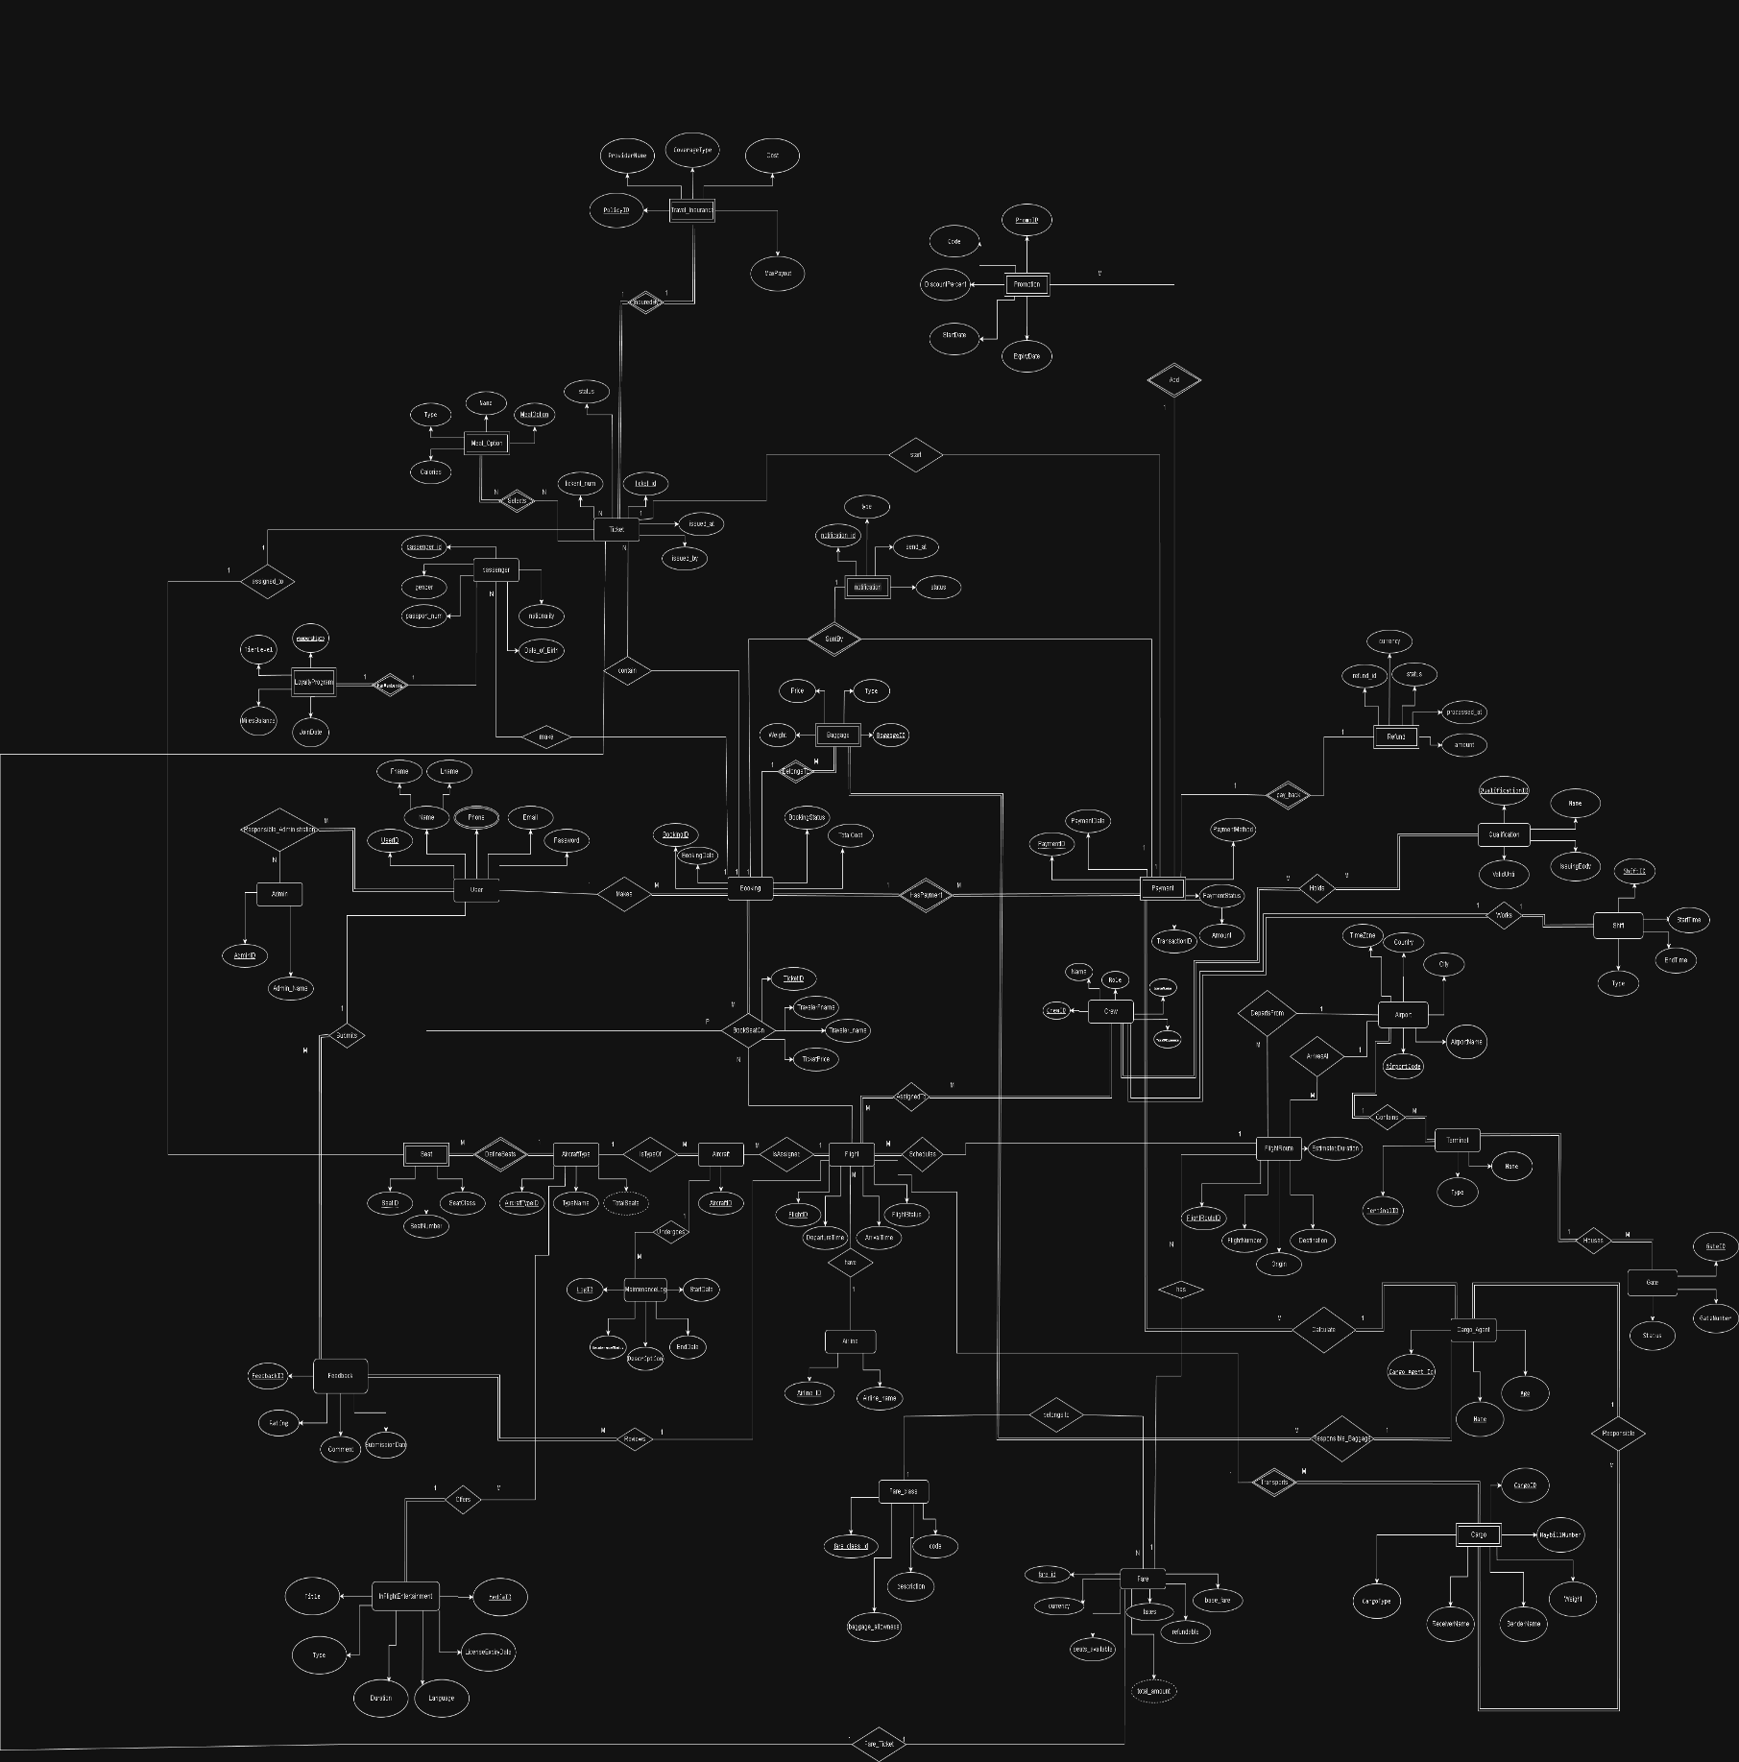

Based on the provided Entity-Relationship Diagram (ERD), the system is built around several core entities that interact to facilitate airline operations. Below is a detailed description of each:
- User: This is a generalized entity (Superclass) representing any individual who interacts with the system. It stores common attributes such as UserID, Name, Email, Password, and Phone Number. The Role attribute differentiates between Administrators and Passengers, ensuring security and proper access control.
- Passenger: A specialized entity (Subclass) inheriting from the User entity. It captures travel-specific data required for international and domestic flights, such as Passport Number, Nationality, Gender, and Date of Birth. This entity is directly linked to bookings and tickets.
- Flight: The central entity of the system that represents a specific scheduled journey. It connects the Route (Where), the Aircraft (Which plane), and the Time (Departure/Arrival). It also tracks the current state of the journey via the FlightStatus attribute (e.g., Scheduled, Delayed, Landed).
- Booking: Represents the transaction header made by a user. It records the BookingDate, TotalCost, and BookingStatus (Confirmed, Pending, Cancelled). A single booking can encompass multiple tickets (e.g., a family reservation), serving as a container for financial tracking.
- Ticket: Represents the actual travel authorization for a single passenger on a specific flight. It links a Booking to a Passenger and assigns specific details such as SeatNumber, Class (Economy, Business), and Price. It acts as a bridge between the commercial transaction and the operational flight.
- Airport: Stores static reference data about locations, identified by a unique AirportCode (e.g., CAI, JFK). It contains geographical details like City, Country, and TimeZone. Airports act as the source and destination points for Routes.
- Route: Defines a standard connection between two airports (Origin and Destination). By separating Routes from Flights, the system can manage recurring schedules (e.g., "Cairo to London") independently of the specific daily flight instances.
- Aircraft & Aircraft Type: This section is split into two entities to normalize data. AircraftType defines the model specifications (e.g., Boeing 747) and TotalSeats. Aircraft represents the physical physical plane identified by a tail number or ID, linked to a specific type, allowing the airline to manage its fleet inventory effectively.
- Crew & Staff: Represents the employees operating the flights, such as Pilots and Flight Attendants. It tracks their Role, Experience, and assignments to specific flights, ensuring that every flight is adequately staffed according to safety regulations.

Chapter 3: Logical Design (Mapping)

3.1 Relational Schema Description

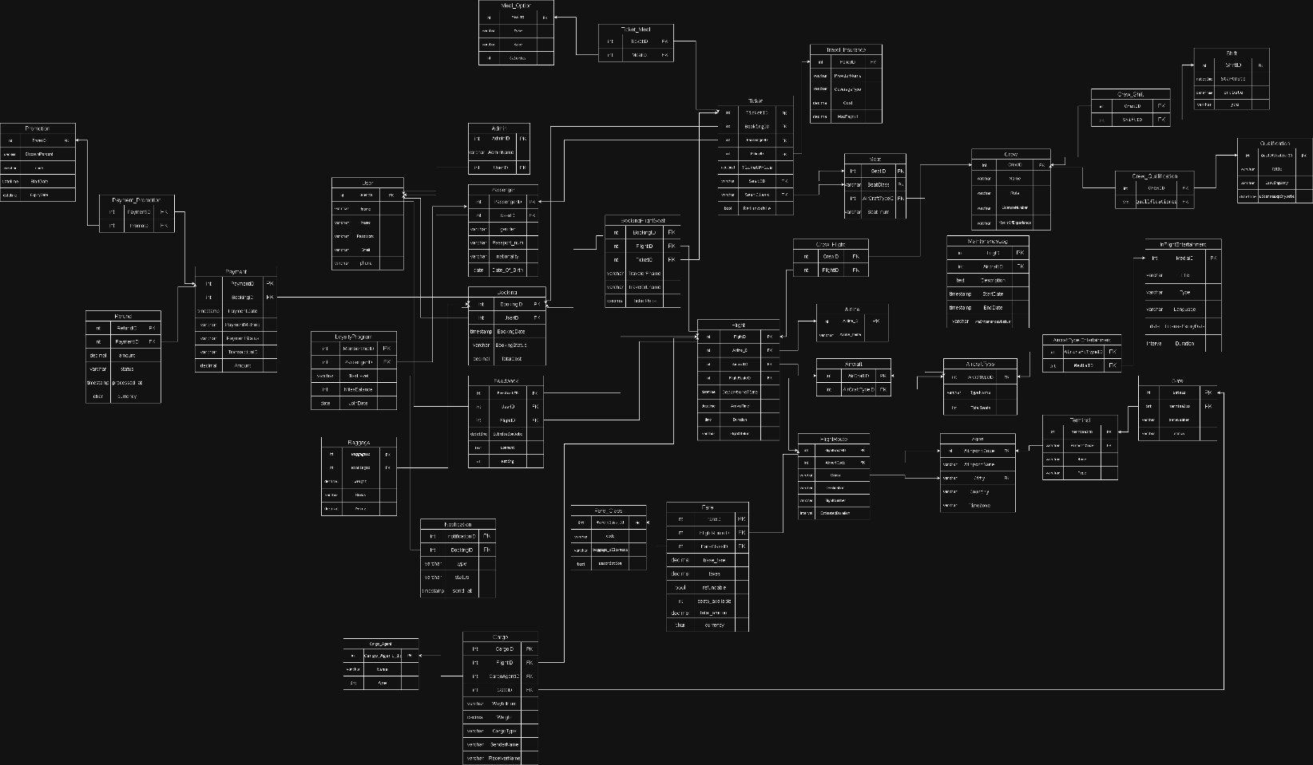

The logical schema is organized into functional modules to clarify the relationships between entities. The following list details the attributes for each relation, where <u>Underlined</u> attributes represent Primary Keys (PK) and Italicized attributes represent Foreign Keys (FK).
A. User Management & Administration
These tables handle user authentication, profiles, and role-based specialization.
- User (<u>UserID</u>, Fname, Lname, Password, Email, Phone, Role)
  - Description: The parent table for all system users, storing login credentials and contact info.
- Passenger (<u>PassengerID</u>, UserID, Gender, Passport_Num, Nationality, DateOfBirth)
  - Description: An extension of the User table containing specific travel documents and demographic data.
- Admin (<u>AdminID</u>, UserID, AdminName)
  - Description: Represents administrative staff with access to backend operations.
B. Infrastructure & Location
These tables define the physical hierarchy of airports and terminals.
- Airport (<u>AirportCode</u>, AirportName, City, Country, TimeZone)
  - Description: The root entity for locations, identified by standard IATA codes.
- Terminal (<u>TerminalID</u>, AirportCode, Name, Type)
  - Description: Specific terminals within an airport (International/Domestic).
- Gate (<u>GateID</u>, TerminalID, GateNumber, Status)
  - Description: The physical boarding points linked to specific terminals.
C. Flight Operations & Fleet
These tables manage the core airline product: the flights and the aircraft used.
- Airline (<u>Airline_ID</u>, Airline_Name)
  - Description: The operating carrier for the flights.
- AircraftType (<u>AircraftTypeID</u>, TypeName, TotalSeats)
  - Description: Defines the model specifications and capacity limits.
- Flight (<u>FlightID</u>, Airline_ID, AircraftID, FlightRouteID, DepartureTime, ArrivalTime, Duration, FlightStatus)
  - Description: The central transaction table linking a specific plane, route, and time.
D. Booking & Transactions
These tables handle the commercial aspect, reservations, and ancillary services.
- Booking (<u>BookingID</u>, UserID, BookingDate, BookingStatus, TotalCost)
  - Description: Represents the financial transaction header for a user.
- Ticket (<u>TicketID</u>, BookingID, PassengerID, PolicyID, TicketPrice, SeatID, SeatClass, Refundable)
  - Description: The individual travel permit. It links a passenger to a specific seat and insurance policy.
- Baggage (<u>BaggageID</u>, BookingID, Weight, Status, Price)
  - Description: Tracks luggage associated with a booking for weight management.
- Promotion (<u>PromoID</u>, DiscountPercent, Code, StartDate, ExpiryDate)
  - Description: Marketing codes used to apply discounts to bookings.
- Travel_Insurance (<u>PolicyID</u>, ProviderName, CoverageType, Cost, MaxPayout)
  - Description: Optional insurance policies linked to tickets.
- Meal_Option (<u>MealID</u>, Type, Name, Calories)
  - Description: Menu choices available for in-flight service.
E. Customer Engagement
- Feedback (<u>FeedbackID</u>, UserID, FlightID, SubmissionDate, Comment, Rating)
  - Description: Captures user satisfaction regarding specific flights.

Chapter 4: Optimization & Normalization
4.1 Normalization Verification
To ensure data integrity and reduce redundancy, the database schema was rigorously tested against normalization forms. We have verified that the design complies with 1NF, 2NF, and 3NF as follows:
- First Normal Form (1NF): All tables were tested for atomicity. No multivalued attributes (such as multiple phone numbers in one cell) exist; separate tables or atomic columns were used where necessary. All records are unique and identified by a Primary Key.
- Second Normal Form (2NF): The schema was analyzed for partial dependencies. All non-key attributes in every table are fully dependent on the entire Primary Key, not just a part of it. This is particularly relevant for bridge tables (e.g., ticket-meal relations), where attributes depend on the composite key.
- Third Normal Form (3NF): We verified that no transitive dependencies exist. Attributes depend only on the Primary Key and not on other non-key attributes (e.g., City depends on AirportCode, not on the Flight directly).
4.2 Relational Algebra (Query Optimization)
The following section documents the Relational Algebra expressions used to optimize system queries. These 45 queries cover various operations including Selection (σ), Projection (π), Join (⋈), and Aggregation (F).
- Usernames and phone numbers R ← π Fname, Lname, Phone (User ⋈ User_Phone)
- Airports in Egypt EgyptAirports ← σ Country='Egypt' (Airport) R ← π AirportName, City (EgyptAirports)
- American or British passengers Pass ← σ Nationality='American' ∨ Nationality='British' (Passenger) R ← π Fname, Lname, Nationality (Pass)
- Flights per Airline R ← AirlineName F COUNT(FlightID) (Airline ⋈ left Flight)
- Total Revenue from Confirmed Bookings Confirmed ← σ BookingStatus='Confirmed' (Booking) R ← F SUM(TotalCost) (Confirmed)
- Pilots with > 10 years experience ExpertPilots ← σ Role='Pilot' ∧ YearsOfExperience>10 (Crew) R ← π Fname, Lname (ExpertPilots)
- Delayed Flights Delayed ← σ FlightStatus='Delayed' (Flight) R ← π FlightRouteID, DepartureTime, FlightStatus (Delayed)
- Avg seat capacity per Aircraft Type R ← TypeName F AVG(TotalSeats) (AircraftType ⋈ Aircraft)
- Total tickets for MS800 Route ← σ FlightNumber='MS800' (FlightRoute) Tickets ← Ticket ⋈ Flight ⋈ Route R ← F COUNT(TicketID) (Tickets)
- Top 3 Miles (Ordered) R ← π Fname, Lname, MilesBalance (SORT MilesBalance DESC (User ⋈ LoyaltyProgram))
- Vegan meals < 500 calories V_Meals ← σ Type='Vegan' ∧ Calories<500 (MealOption) R ← π Name, Calories (V_Meals)
- Crew and Shift types R ← π Fname, Lname, Type (Crew ⋈ Crew_Shift ⋈ Shift)
- Total weight for Ticket 1 T1_Baggage ← σ TicketID=1 (Baggage) R ← F SUM(Weight) (T1_Baggage)
- Most used payment method (No Aggregation for Max) Used ← PaymentMethod F COUNT(*) (Payment) NotMax ← π U1.PaymentMethod (σ U1.Count < U2.Count (ρ U1(Used) × ρ U2(Used))) R ← π PaymentMethod (Used) - NotMax
- Aircraft in 'In Progress' maintenance R ← π AircraftID (σ MaintenanceStatus='InProgress' (MaintenanceLog))
- Rank passengers within Nationality (Self-Join for Rank) HighPrice ← π T1.TicketID, T2.TicketID (σ T1.Nationality=T2.Nationality ∧ T1.Price < T2.Price (ρ T1(Pass ⋈ Tkt) × ρ T2(Pass ⋈ Tkt))) R ← T1.TicketID F COUNT(T2.TicketID) (HighPrice)
- Spend > Average (CTE Style) UserSpend ← UserID F SUM(TotalCost) (Booking) AvgSpend ← F AVG(SumCost) (UserSpend) R ← π Fname, Lname, SumCost (User ⋈ UserSpend ⋈ SumCost > AvgCost AvgSpend)
- Landed Flight Durations Landed ← σ FlightStatus='Landed' (Flight) R ← π FlightID, FlightNumber, (ArrivalTime - DepartureTime) (Landed ⋈ FlightRoute)
- Active Tickets Multi-Join Active ← σ Status='Active' (Ticket) R ← π Fname, Lname, FlightNumber, AirlineName, GateNumber (Passenger ⋈ Active ⋈ Flight ⋈ Airline ⋈ FlightRoute ⋈ Flight_Gate ⋈ Gate)
- Status counts per User R ← UserID F COUNT(Confirmed), COUNT(Pending), COUNT(Cancelled) (Booking)
- Running Total of Payments R ← π P1.PaymentDate, P1.Amount, SUM(P2.Amount) (ρ P1(Payment) ⋈ P1.Date ≥ P2.Date ρ P2(Payment))
- Crew with ATPL Qualification ATPL ← σ Title='ATPL' (Qualification) R ← π Fname, Lname (Crew ⋈ Crew_Qualification ⋈ ATPL)
- Most popular destination city Count ← City F COUNT(TicketID) (Airport ⋈ FlightRoute ⋈ Flight ⋈ Ticket) NotMax ← π C1.City (σ C1.Count < C2.Count (ρ C1(Count) × ρ C2(Count))) R ← π City (Count) - NotMax
- Flights with no bookings (Left Join/Difference) AllFlights ← π FlightID (Flight) BookedFlights ← π FlightID (Booking ⋈ Ticket ⋈ Flight) R ← AllFlights - BookedFlights
- Passengers on same flight as 'John Doe' JD_Flight ← π FlightID (σ Fname='John' ∧ Lname='Doe' (User ⋈ Passenger ⋈ Ticket ⋈ Flight)) R ← π Fname, Lname (Passenger ⋈ Ticket ⋈ Flight ⋈ JD_Flight)
- Revenue per Aircraft Type R ← TypeName F SUM(TicketPrice) (AircraftType ⋈ Aircraft ⋈ Flight ⋈ Ticket)
- Maintenance Costs > 5000 Expensive ← σ Cost > 5000 (MaintenanceLog) R ← π AircraftID, Description, Cost (Expensive)
- Users with multiple bookings Counts ← UserID F COUNT(BookingID) (Booking) Multiple ← σ Count > 1 (Counts) R ← π Fname, Lname (User ⋈ Multiple)
- Flights arriving after 10 PM Late ← σ ArrivalTime > '22:00:00' (Flight) R ← π FlightNumber, ArrivalTime (Late ⋈ FlightRoute)
- Staff handling VIP passengers VIP ← σ Type='VIP' (Ticket) R ← π StaffName (Staff ⋈ Flight_Staff ⋈ Flight ⋈ VIP)
- Average delay per Airline Delays ← σ FlightStatus='Delayed' (Flight) R ← AirlineName F AVG(ActualArrival - ScheduledArrival) (Airline ⋈ Delays)
- Tickets with Insurance Insured ← σ PolicyID ≠ NULL (Ticket) R ← F COUNT(*) (Insured)
- Airports with > 10 Gates GateCounts ← AirportCode F COUNT(GateID) (Airport ⋈ Terminal ⋈ Gate) BigAirports ← σ Count > 10 (GateCounts) R ← π AirportName (Airport ⋈ BigAirports)
- Passengers born before 1980 OldPass ← σ DOB < '1980-01-01' (Passenger) R ← π Fname, Lname, DOB (User ⋈ OldPass)
- Flights Full Capacity BookedCount ← FlightID F COUNT(TicketID) (Ticket ⋈ Flight) Full ← σ Count = TotalSeats (BookedCount ⋈ Aircraft ⋈ AircraftType) R ← π FlightID (Full)
- Revenue from Extra Baggage Extra ← σ Weight > 23 (Baggage) R ← F SUM(Price) (Extra)
- Crew working on their birthday Birthday ← σ Day(DOB) = Day(FlightDate) ∧ Month(DOB) = Month(FlightDate) (Crew ⋈ Flight_Crew ⋈ Flight) R ← π Fname, Lname (Birthday)
- Refund Ratio per Airline R ← AirlineName F COUNT(RefundAmount) / SUM(Price) (Airline ⋈ Flight ⋈ Ticket ⋈ Refund)
- Missing Night Shifts All ← π StartDate (Shift) Night ← π StartDate (σ Type='Night' (Shift)) R ← All - Night
- VIP Trigger (Cumulative Spend) Cumulative ← π B1.UID, B1.BID, SUM(B2.Cost) (ρ B1(Booking) ⋈ B1.ID ≥ B2.ID ρ B2(Booking)) R ← π UserID, FlightID (σ Sum ≥ 1000 (Cumulative ⋈ Ticket))
- Total Revenue per Route R ← AirlineName, Route F SUM(TicketPrice + BaggagePrice) (Airline ⋈ Flight ⋈ FlightRoute ⋈ Ticket ⋈ Baggage)
- Rank in Loyalty Tier R ← π UserID, UserName, Tier, Rank (ρ U1(Loyalty) ⋈ θ ρ U2(Loyalty))
- Meal popularity per Route R ← Route, MealName F COUNT(*) (FlightRoute ⋈ Flight ⋈ Ticket ⋈ Ticket_Meal ⋈ MealOption)
- Revenue Efficiency R ← TypeName F SUM(Price) / COUNT(DISTINCT FlightID) (AircraftType ⋈ Aircraft ⋈ Flight ⋈ Ticket)
- Nationality Distribution per Destination Total ← Dest F COUNT() (Ticket ⋈ Route) Nat ← Dest, Nat F COUNT() (Ticket ⋈ Passenger ⋈ Route) R ← π Dest, Nat, (NatDest / TotalDest) * 100

